Homework 1 Report

CSC 4320 Operating Systems

Spring 2018

Name: Jimmy Tran

Email: jtran25@student.gsu.edu

1. Screenshot of program outputs.

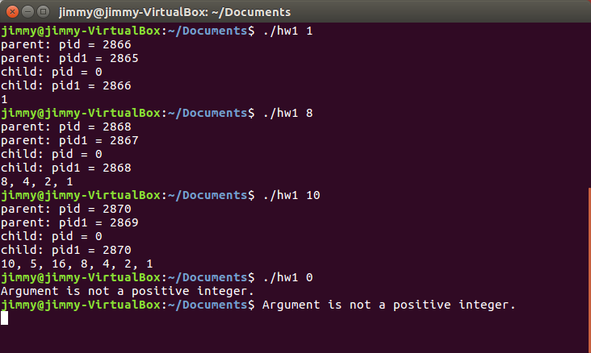

2. Source code

#include <stdio.h>

#include <unistd.h>

#include <sys/types.h>

int main(int argc, char *argv[])

{

pid_t pid, pid1;

int n;

if (argc == 1) {

fprintf(stderr,"Usage: ./a.out <starting value>\n");

return -1;

}

n = atoi(argv[1]);

/* add your code below, following the code structure of Figure 3.34 (page 152) */

pid=fork();

//check if n is positive

if(n<=0){

fprintf(stderr,"Argument is not a positive integer.\n");

return 1;

}

//check if fork fails

if(pid<0){

fprintf(stderr,"Fork failed.");

return 1;

}

else if(pid==0){ //child process

pid1=getpid();

printf("child: pid = %d\n",pid);

printf("child: pid1 = %d\n",pid1);

while(n>1){

if(n%2==0){

printf("%d, ",n);

n=n/2;

}

else{

printf("%d, ",n);

n=(3*n)+1;

}

}

printf("%d\n",n);

}

else{ //parent process

pid1=getpid();

printf("parent: pid = %d\n",pid);

printf("parent: pid1 = %d\n",pid1);

wait(NULL);

}

return 0;

}